Table of Contents
1.0 INTRODUCTION 3
2.0 HOTEL MANAGEMENT SYSTEM DATABASES RAW CODE 4
3.0 HOTEL MANAGEMENT SYSTEM PROCESS AND EXPLAINATION 9
3.1 HMS Database 9
3.2 Creating DATABASE 9
3.3 Creating TABLE / FIELD 10
3.4 Inserting RECORD into FIELD 11
3.4.1 Guests 11
3.4.2 Rooms 11
3.4.3 Reservations 11
3.4.4 Services 12
3.4.5 Employee 13
3.4.6 Invoices 13
3.5 HMS Output with Tables and Records 14
3.5.1 TABLE 14
3.5.2 GUEST RECORDS 14
3.5.3 ROOMS RECORDS 15
3.5.4 RESERVATIONS 15
3.5.5 SERVICES RECORDS 16
3.5.6 EMPLOYEES RECORD 16
3.5.7 INVOICES RECORD 17
4.0 HOTEL MANAGEMENT SYSTEM ERD 18
5.0 HOTEL MANAGEMENT SYSTEM REPORT 19
5.1 Report of which room is available 19
5.2 Report of Guest Status with Contact Information 20
6.0 CONCLUSION 21
7.0 REFERENCE LIST 22

1.0 INTRODUCTION
In this assignment is going to focus about designing and developing a database by using MySQL Workbench as a database administrator. The theme of the database is Hotel Management System (HMS) where it includes six table which is guests, rooms, services, employee, reservations, and invoices information. Each table is related so that is easy to find the correct information.

2.0 HOTEL MANAGEMENT SYSTEM DATABASES RAW CODE
create database hms;
use hms;
create table Guests
(GuestID int, Fname varchar(30),
Lname varchar(30), Email varchar(100),PhoneNumber int
,PRIMARY KEY(GuestID));

create table Rooms
(RoomID int,
RoomType varchar(15), RoomStatus varchar(10),
PRIMARY KEY(RoomID));

create table Reservations
(ReservationID varchar(10), GuestID int,
RoomID int, CheckInDate date,CheckOutDate date
, ReservationStatus varchar(25),
primary key (reservationid),
foreign key (guestid) references guests(guestid),
foreign key (roomid) references rooms(roomid));

create table Services
(ServiceID varchar(15), ServiceName varchar(30),
ServiceDesc varchar(100), ServicePrice float
,primary key (serviceid));

create table Employee
(EmployeeID varchar(10), Fname varchar(30),
Lname varchar(30), Email varchar(100),PhoneNumber int
, Position varchar(40), ServiceFocuseson varchar(15)
,primary key (employeeid)
,foreign key (servicefocuseson) references services(ServiceID));

create table Invoice
(InvoiceID varchar(10), ReservationID varchar(10),
ServiceID varchar(15), Amount float,InvoiceDate date
,primary key (invoiceid)
,foreign key (reservationid) references Reservations(ReservationID)
,foreign key (serviceid) references services(serviceid));

-- test--
show tables;
select*from guests;
select*from rooms;
select*from reservations;
select*from Services;
select*from employee;
select*from invoice;

alter table reservations change column ReservationID
ReservationID varchar(10) primary key;
alter table employee change column phonenumber
phonenumber int;
-- test--

insert into Guests values(1001001,'Rick',' Anderson','rickanderson@hotmail.com',60118539933);
insert into Guests values
(1001002,'Steven',' Onyx','stevenoynx@hotmail.com',601143535),
(1001003,'Mike',' Peterson','mikepeterson@hotmail.com',601985623),
(1001004,'Tay',' KiaWin','kiawintay@hotmail.com',601400432),
(1001005,'Eddy',' Tok','eddytok04@hotmail.com',601534891),
(1001006,'Cheok','Eyoree','eyoreecheok@hotmail.com',601563592);

INSERT INTO Rooms values(101, 'Standard', 'Available');
INSERT INTO Rooms values(102, 'Deluxe', 'Occupied');
INSERT INTO Rooms VALUES
(103, 'Deluxe', 'Occupied'),
(104, 'Deluxe', 'Available'),
(105, 'Supreme', 'Occupied'),
(106, 'Suite', 'Available'),
(201, 'Suite', 'Occupied'),
(202, 'Supreme', 'Available'),
(203, 'Supreme', 'Available'),
(204, 'Standard', 'Available'),
(205, 'Deluxe', 'Occupied'),
(206, 'Standard', 'Occupied');

INSERT INTO Reservations VALUES ('R001', 1001001, 102, '2023-07-10', '2023-07-15', 'Confirmed');
INSERT INTO Reservations VALUES ('R002', 1001002, 103, '2023-08-10', '2023-08-26', 'Confirmed')
,('R003', 1001003, 105, '2023-07-02', '2023-07-11', 'Pending')
,('R004', 1001004, 201, '2023-07-02', '2023-07-27', 'Confirmed')
,('R005', 1001005, 205, '2023-07-20', '2023-07-29', 'Pending')
,('R006', 1001006, 206, '2023-08-05', '2023-08-15', 'Confirmed');

INSERT INTO Services VALUES ('S100', 'Room Service', 'Food and drinks delivered to the room', 30.00);
INSERT INTO Services VALUES ('S102', 'Meeting Rooms', 'Basic Presentation Equipment', 36.00);
INSERT INTO Services VALUES ('N100', 'No Service', 'No Service', 00.00);
INSERT INTO Services VALUES
('S103', 'Laundry Service', 'Washing and ironing of clothes', 25.50),
('S104', 'Spa Package', 'Relaxing Spa treatments', 75.60),
('S105', 'Airport Transfer', 'Pickup and drop-off service to the airport', 25.30),
('S101', 'Fitness Center', 'Access to the hotel fitness center', 5.50),
('S106', 'Business Center', 'Use of business facilities and services', 10.70);

INSERT INTO employee VALUES ('E1001', 'George', 'Johnson', 'georgejohnson@hotmail.com',122345677, 'Front Desk Manager','S102');
INSERT INTO employee VALUES ('E1002', 'Kaine', 'Roast', 'kaineroast@hotmail.com',597830421, 'Front Desk Assistant','S101')
,('E1003', 'Robin', 'Jager', 'robinjager@hotmail.com',605947881, 'Navigator','S105')
,('E1004', 'Jake', 'Combrass', 'jakecombrass@hotmail.com',605312122, 'Temporary Part Timer','S106')
,('E1005', 'Lee', 'Maker', 'leemaker@hotmail.com',605948853, 'Receptionist','S104')
,('E1006', 'Haris', 'Bob', 'harisbob@hotmail.com',601223991, 'Housekeeping','S103')
,('E1007', 'June', 'Ioki', 'juneioki@hotmail.com',605999324, 'Chef','S100')
,('E1008', 'Steve', 'Alpha', 'stevealpha@hotmail.com',604958821, 'Waiter','S100')
,('E1009', 'Quint', 'Hillsen', 'quinthillsen@hotmail.com',605311297, 'Temparary Part Timer','N100');

INSERT INTO Invoice VALUES
('I1001', 'R001', 'N100', 0.00, '2023-07-10'),
('I1002', 'R002', 'S105', 25.30, '2023-08-10'),
('I1003', 'R002', 'S100', 30.00, '2023-08-10'),
('I1004', 'R004', 'S100', 30.00, '2023-07-02'),
('I1005', 'R004', 'S102', 36.00, '2023-07-02'),
('I1006', 'R006', 'S100', 30.00, '2023-08-05'),
('I1007', 'R002', 'S103', 25.50, '2023-08-10'),
('I1008', 'R004', 'S106', 10.70, '2023-07-02'),
('I1009', 'R006', 'S101', 5.50, '2023-08-05'),
('I1010', 'R006', 'S104', 75.60, '2023-08-05');

3.0 HOTEL MANAGEMENT SYSTEM PROCESS AND EXPLAINATION

3.1 HMS Database
HMS Database contain six tables, and each has its own name. There are Guests, Rooms, Reservations, Services, Employees, and Invoice exist in this database field.

3.2 Creating DATABASE
Start by creating a database named “HMS”
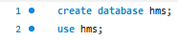

3.3 Creating TABLE / FIELD
After creating HMS, six table is created by the following command that is shown below the images.
HMS
ROOMS
GUESTS
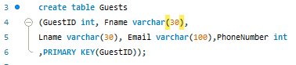
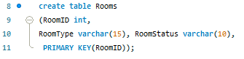

EMPLOYEE
SERVICES
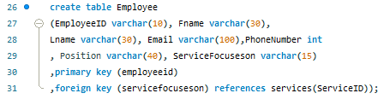
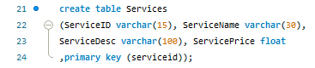

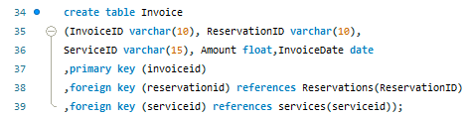
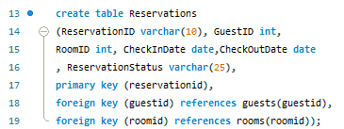
Figure 1 3.3 Process of creating table
INVOICE
RESERVATIONS

3.4 Inserting RECORD into FIELD

3.4.1 Guests

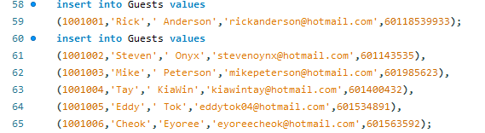
Figure 2 Process of inserting guests record

3.4.2 Rooms
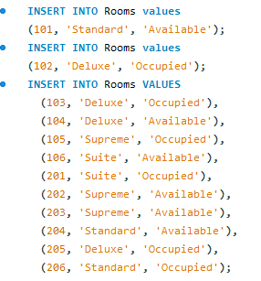
Figure 3 Process of inserting rooms record

3.4.3 Reservations

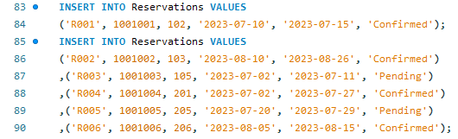
Figure 4 Process of inserting reservations record

3.4.4 Services

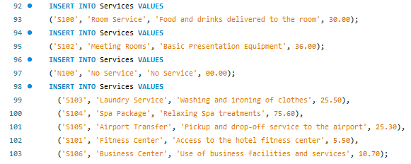
Figure 5 Process of inserting Services record

3.4.5 Employee

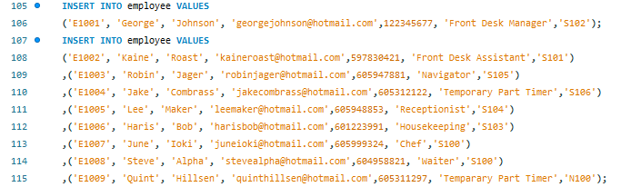
Figure 6 Process of inserting employee record

3.4.6 Invoices

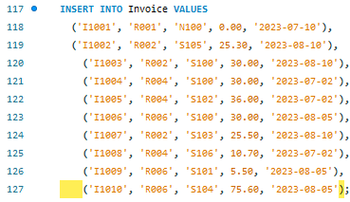
Figure 7 Process of inserting invoices record

3.5 HMS Output with Tables and Records

3.5.1 TABLE
show tables;
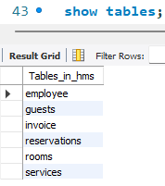
Figure 8 Output of tables

3.5.2 GUEST RECORDS
select*from guests;
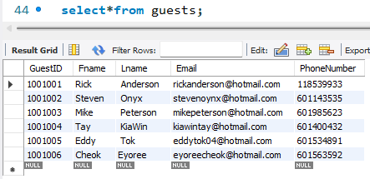
Figure 9 Output of guests

3.5.3 ROOMS RECORDS
select*from rooms;
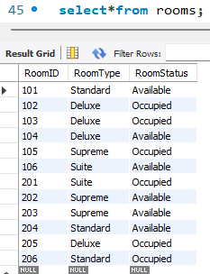
Figure 10 Output of rooms

3.5.4 RESERVATIONS
select*from reservations;
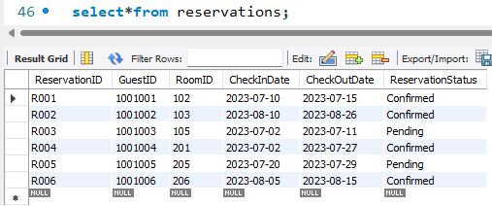
Figure 11 Output of reservations

3.5.5 SERVICES RECORDS
select*from Services;
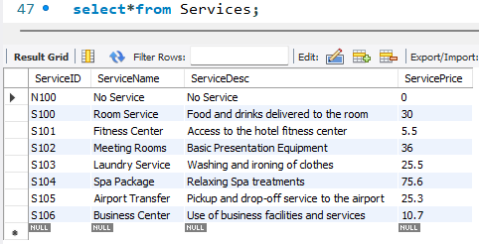
Figure 12 Output of services

3.5.6 EMPLOYEES RECORD
select*from employee;
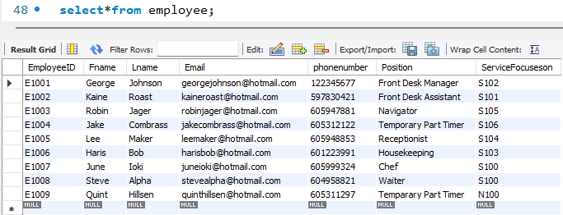
Figure 13 Output of employee

3.5.7 INVOICES RECORD
select*from invoice;
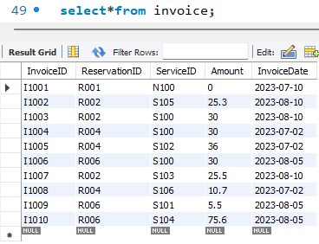
Figure 14 Output of invoices

4.0 HOTEL MANAGEMENT SYSTEM ERD
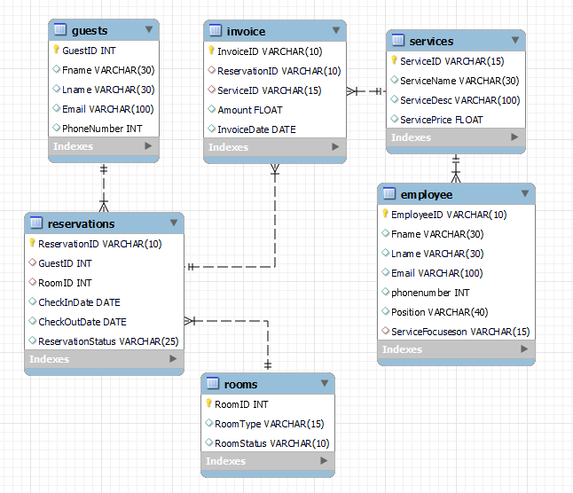
Figure 15 ERD

5.0 HOTEL MANAGEMENT SYSTEM REPORT

5.1 Report of which room is available
SQL Command
select * from rooms where roomstatus='available';
Output
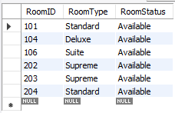
Figure 16 Report 1
This is to show which room is available for new guest or guest that need to change their Room type. For the employee perspective, it is easier for them to check on live when new guest arrives at the Hotel.

5.2 Report of Guest Status with Contact Information
SQL Command
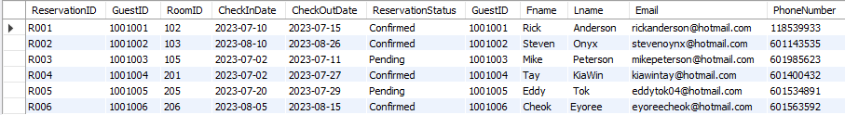
select * from reservations inner join guests on reservations.guestid=guests.guestid;
Figure 17 Report2

This list of record show almost every information from the guest such as check in date, reservation status and contact number. This record can let the employee know which guest is confirmed staying in this hotel or not.

6.0 CONCLUSION

In Conclusion, Hotel Management System database is pretty simple to handle if there is not much data being stored inside. HMS has six table and all of them are related. ERD is to show how to database is linked together. The purpose for the report is to show how useful the information it is for our data.

7.0 REFERENCE LIST
1. March 20, N., documentation, 2022-2:39 P.C. you send hotel management project with whole, Vb.net, S.C.U. and Reply, sql server (2019). Database Table For Hotel Management System. [online] Student Project Guidance & Development. Available at: https://studentprojectguide.com/project-report/database-design/database-table-for-hotel-management-system/

2. Post, G. (2021). 11 Types of Service in the Hotel Industry to Attract Customers. [online] Asksuite | Hotel Chatbot. Available at: https://asksuite.com/blog/types-of-service-in-hotel-industry/

‌

